Evaluation of Questionnaires – Ukraine
As part of the project, a uniform questionnaire has been prepared and sent out to various stakeholders and experts. We received 67 relevant responses. Targeted organizations included: ministries and other policy actors, SME organizations, agricultural associations, think tanks and expert groups, banks dealing with SME financing and local representatives of international organizations.
Hereby we analyze the results of the replies. The questionnaire was translated into Ukrainian. In this analysis, we use the English terms of the questionnaire.
In the first part of the questionnaire template, respondents were asked to evaluate, to what extent the factors listed were impeding the development and activities of SMEs in the country. On a 1-4 scale, 1 represented “not at all”, 2 represented “somewhat”, 3 stood for “significantly”, 4 meant “very significantly”. NA was provided when the respondent did not / could not answer. Respondents were asked to mark “help” in case they think that an intervention by the GMU Project would be advised and welcome. However, the “help” answers were infrequent (see below).
The questions targeted six domains relevant for the development and daily activities of SMEs. The main domains were:
- Labor and skills,
- Red tape/bureaucracy,
- Tax burdens,
- Law and order,
- Market specificities,
- Finance and other issues.
In the table below, we provide the average value of the responses given to the seriousness of the obstacle (without the “NA” answers), and the number of “help” responses out of the 67 respondents, who considered that the project and V4-GMU experiences could add to the solution of the given problem.
Further, we highlight/discuss the most significant and other interesting results of the survey and provide important comments by the respondents.
Summary of Results
Nr | Domain/Obstacle | average of responses to seriousness of problem | nr of "help" responses
1 | Labor & Skills
A | Low market skills of entrepreneurs / Inadequate business education | 2.55 | 0
B | Lack of business experience | 2.18 | 1
C | Lack of experience in foreign trade, in EU in particular | 2.93 | 3
D | Lack of knowledge of EU regulations | 3.07 | 4
E | Lack of language skills and contacts abroad | 2.88 | 1
F | Low availability of high skill workers | 2.73 | 1
G | Low availability of low-skill workers | 1.79 | 1
H | Demographics / low number of young labor market entrants | 1.86 | 0
I | High emigration | 1.56 | 0
J | Expensive labor / Mismatch between labor cost and productivity | 2.03 | 0
K | Employer-employee conflicts | 1.85 | 0
L | Low labor market flexibility | 2.07 | 0
M | High syndicalization / Excessive power of labor unions | 2.25 | 0
N | Low labor ethics | 2.59 | 1
O | Low business ethics | 2.65 | 1
2 | Red Tape / Bureaucracy
A | Difficulties in registering company | 1.98 | 0
B | High cost of market entry | 2.92 | 0
C | Difficulties to expand business activities / bureaucratic obstacles | 3.08 | 0
D | Non-transparent / inconsistent regulations | 3.22 | 0
E | Poor overall regulatory framework / Excessive burden of regulations | 3.29 | 0
F | Foreign trade barriers | 2.82 | 0
G | Institutional differences with EU | 2.91 | 0
3 | Tax burden
A | Unstable and non-transparent tax rules and/or their applications | 3.27 | 0
B | High cost of compliance | 3.00 | 0
C | High effective SME presumptive tax rates | 3.06 | 1
D | High effective personal income tax rates | 2.71 | 0
E | High effective corporate income tax rates | 2.84 | 0
F | High effective value added tax / trade tax rates | 3.15 | 0
G | High custom charges | 2.71 | 1
H | Other high taxes and fiscal fees/charges | 2.89 | 1
4 | Law and order
A | Weak property rights / weak contract enforcement | 3.06 | 0
B | Crime and violence (low safety) | 2.80 | 0
C | Corruption / Clientelism / Favoritism | 3.47/3.42/3.42 | 0/0/0
D | Weak judiciary | 3.59 | 0
5 | Market
A | Small market size / Weak demand | 2.82 | 0
B | Barriers for exports to foreign markets | 2.79 | 0
C | Unfair competition / Uneven playing field / Informal economy | 3.09/3.11/2.69 | 0/0/2
D | Monopolization / Excessive market power of some participants | 2.95 | 1
E | Weak market position of SMEs | 2.89 | 1
F | Weak professional organizations of SMEs | 2.81 | 2
G | Weak analytical and policy advocacy of SME organizations | 2.76 | 1
H | Discriminatory practices of authorities | 3.11 | 0
I | Unfair privileges for foreign investors | 2.18 | 1
J | Macroeconomic instability (demand, inflation, exchange rate) | 3.28 | 0
K | Political instability | 3.52 | 0
L | Insufficient market information/governmental support for SMEs | 2.71/2.75 | 0
M | Weak support/lack of support by international organizations | 2.51 | 1
N | Low level of activities of venture capital | 2.48 | 1
6 | Finance and other
A | Difficulties in accessing financial services | 2.89 | 0
B | High cost of credit | 3.52 | 1
C | Inappropriate infrastructure | 2.97 | 0
D | Weak professional organizations of SMEs | 2.86 | 1
E | Difficult access to internet / Lack or low quality of business websites | 1.55 | 0
F | Lack of open communication channels with EU | 2.44 | 0

Significant Results
- Poor overall regulatory framework / Excessive burden of regulations: 3.29 out of 4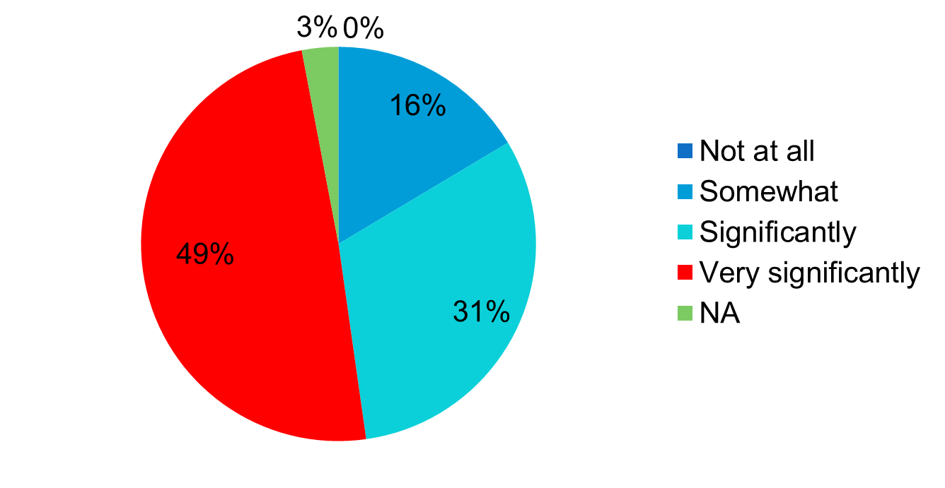
Related: Non-transparent / inconsistent regulations: 3.22.

- Difficulties to expand business activities / bureaucratic obstacles: 3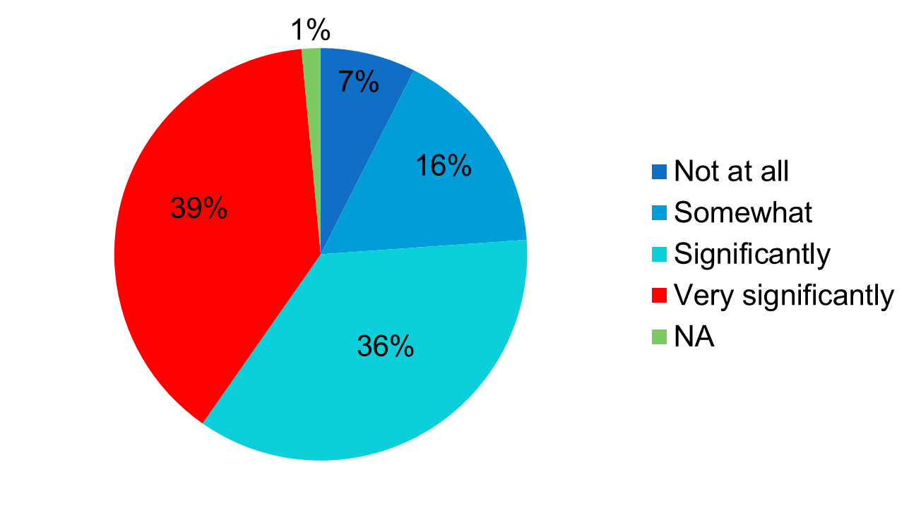

- Unstable and non-transparent tax rules and/or their applications: 3.27
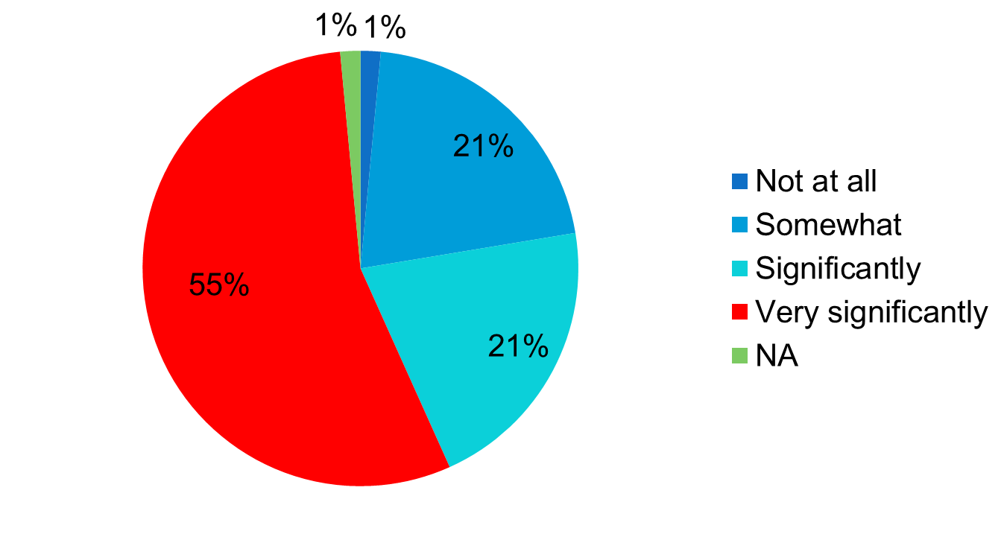
Related: High effective SME presumptive tax rates: 3.06 and High effective value added tax / trade tax rates: 3.15.

- Corruption: 3.47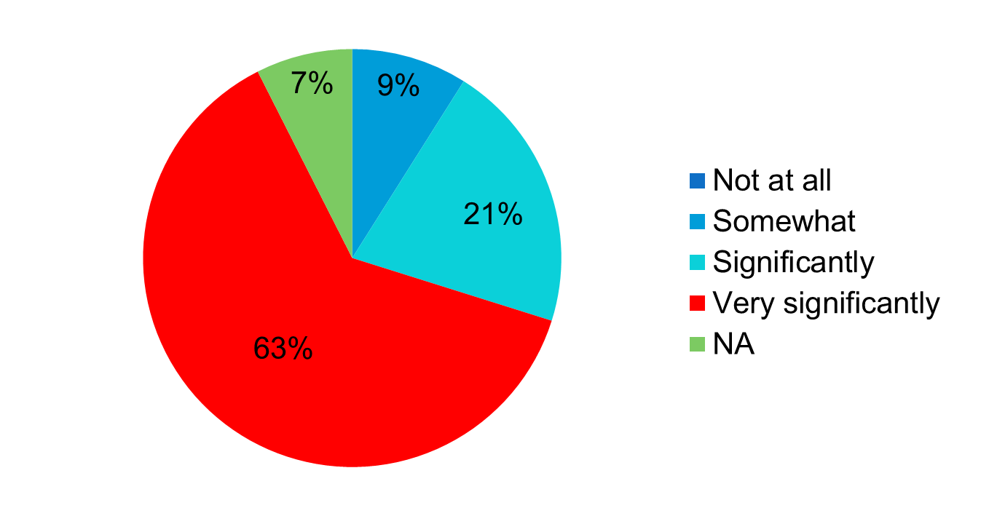
Related: Weak property rights / weak contract enforcement: 3.06 and Weak judiciary system: 3.59.
- Lack of knowledge of EU regulations: 3.07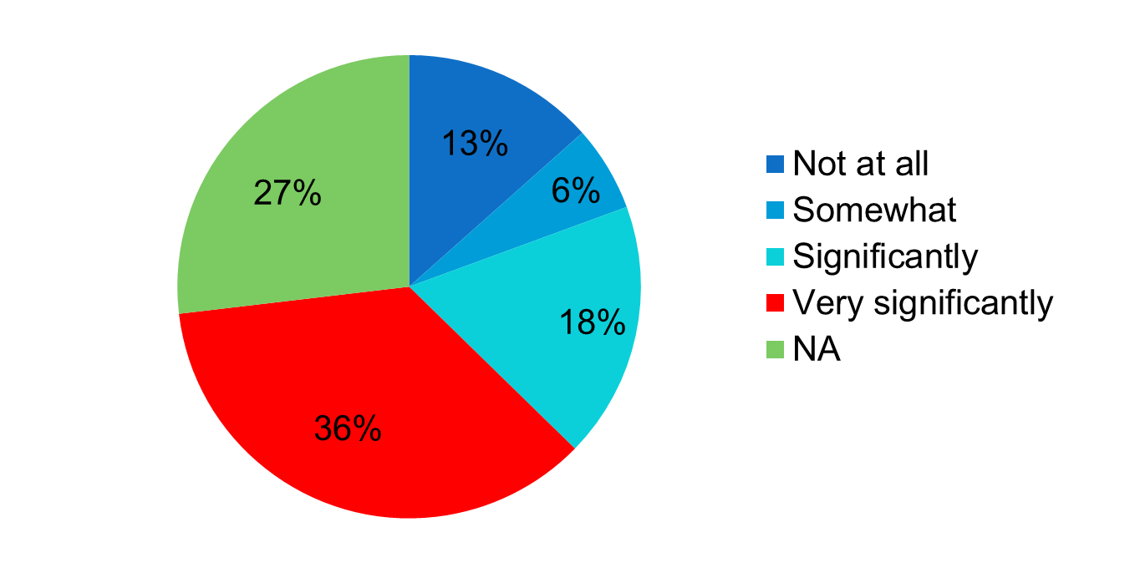

More Selected Results
High Impediments:
- Unfair competition: 3.09
- Discriminatory practices of authorities: 3.11
- Macroeconomic instability: 3.28
- Political instability: 3.52
- High cost of credit: 3.52
Low/Moderate Impediments:
- High syndicalization / Excessive power of labor unions: 1.25
- Difficult access to internet / Lack or low quality of business websites: 1.55
- Employer-employee conflicts: 1.85
- Demographics - low number of young labor market entrants: 1.86
- Difficulties in registering company: 1.98
- Unfair privileges for foreign investors: 2.18
- Lack of business experience: 2.18
- Lack of open communication channels with EU: 2.44

Major Comments by Respondents
- Eliminate bureaucracy and corruption, build supply chain for products in Europe;
- Inform entrepreneurs on norms and standards in Europe for its products as well as a list of required documents and processes for their preparation;
- Provide simplified licensing procedures (permissions to begin the production, should take no longer than 5 working days in general);
- Allow to produce any product that is not prohibited by law.
Final Comments

- Language issues (besides translations, typical for this kind of research: do we have the same in mind/semantics)?
- Problematic: e. g. how to interpret lack of business experience? Do we know or we just don’t know that we don’t know?
- Reliability (various from general attitude of respondents to these kinds of activities to the current situation in Ukraine, bias)

According to the small focus-group research conduced in Spring, 2013 (Dubrovskiy, 2013), non-performing court system and blatant violation of the law by the bureaucrats were named among the most important impediments. These problems have more than offset the most of government’s efforts in deregulation. Another major problem in this area was deliberately poor targeting of those efforts: instead of focusing on the really most important impediments for entrepreneurship, the government tried and succeeded in the improvement of the Doing Business ratings as themselves (a “façade” deregulation). And, of course, the entrepreneurs complained for extremely poor protection of the property rights, to put it mildly. In fact, exactly those “law enforcement” agencies that would be expected to exercise such a protection were the main violators.
Such extremely poor performance of the market and law enforcement institutions are confirmed by the detailed WEF’s ranking. Namely, Ukraine is rated 143 (out of 148 countries) in “Property rights” – and not due to the notoriously poor protection of the intellectual ones; 144 and 146 in the “Efficiency of legal framework” in settling disputes and challenging regulations respectively; 139 in “Judicial independence”, etc. All these indicators have been deteriorating during the Yanukovich times. In combination with other adverse factors, fist of all increasing tax pressure and lack of access to financing (in turn, to large extent related to the poor protection of property rights), this led to sharp decrease in the number of business entities per capita (from 67 per 1000 of population in 2009 to 35 in 2012) accompanied by equally sharp decrease in employment at the SME sector: for about 2 mln. of employed (including the entrepreneurs and self-employed), which constituted about 1/3 of total employment in the SME sector in 2009. These adverse developments were at the core of current economic crisis in Ukraine.
There is a hope that after ousting of Yanukovich some real reforms will start that would allow for real improvement in the business conditions that are badly needed for renovation of growth. The new Ukrainian authorities are quite sensitive to the recommendations and pressure of the civil society that, in its turn, has got vibrant due to Maidan.

